Mercury Credential

– User Guide for Clinicians –

Last Updated: 07 October 2016
Version: v1.66

No part of this publication may be reproduced or transmitted, in any form or by any means, without the prior written permission of the publisher.
© 2017 Mercury. All rights reserved.
Whilst every care has been taken to ensure that the information presented in this publication is correct, the author makes no warranty of any kind, expressed or implied, with regard to this information.
All product names mentioned herein are the trademarks of their respective owners.
Produced in Australia by Mercury, Melbourne Australia.

Contents
1 Getting started & Managing your account 2
1.1 Launch Mercury Credential 3
1.2 Navigating myclinicalprofile.com.au 4
1.3 Register & Create a new Mercury Credential account 4
1.4 Forgotten your Password? Logging in for the first time? 8
1.5 Navigating & Managing your profile page 10
1.6 Change your username 11
1.7 Update your password 11
1.8 Review / Print / Download your profile 11
1.9 Manage your profile image 12
1.9.1 Upload a profile image 12
1.9.2 Change your profile image 12
1.9.3 Delete your profile image 12
1.10 Deactivate your Account 12
2 Completing and updating your profile 14
2.1 Complete / Update your Mercury Credentialential profile 14
2.1.1 Personal Details (Step 1 of 10) 14
2.1.2 Contact Details (Step 2 of 10) 16
2.1.3 Qualifications (Step 3 of 10) 17
2.1.4 Employment History (Step 4 of 10) 18
2.1.5 Registration (Step 5 of 10) 19
2.1.6 Insurance Information (Step 6 of 10) 21
2.1.7 Academic Appointments / Teaching Experience (Step 7 of 10) 23
2.1.8 Professional Development (Step 8 of 10) 24
2.1.9 Background Checks (Step 9 of 10) 26
2.1.10 Referees (Step 10 of 10) 28
3 Submitting your profile for Credentialing 29
3.1 Submit your Profile against a position 29
3.2 Requests requiring further details 32
3.3 Manage who has access to your Account 32
4 Update Expired Details with Registered Health Services 34
5 Index 37

Getting started & Managing your account

Mercury Credential is an online credentialing system which provides an organisation the ability to manage the end to end credentialing process online.

Mercury Credential provides a self-manageable, centralised clinical profiling system which enables health practitioners and staff members to create and manage their own online career profile in a central, accessible and secure location: https://myclinicalprofile.com.au/

Mercury Credential eliminates the need for paper-based processes, improves efficiency and ensures important actions are not missed.

Details can be kept up to date and easily submitted to organisations for consideration against open positions, or for re-credentialing.

In this section, learn how to:
- Launch Mercury Credential
- Log into your account
- Change your username
- Change / reset your password
- Review, Print or Download your profile
- Manage your profile image
- Deactivate your account

Launch Mercury Credential
- Access Mercury Credential using a web browser, such as Microsoft® Internet Explorer, Firefox, Chrome or similar.
- Type http://myclinicalprofile.com.au/ in the Address field at the top of the browser screen.
- Click Enter > The Mercury Credential system displays:

TIP | After you launch Mercury Credential, add this page to your Favourites in your browser for quick access to Mercury Credential.

Navigating myclinicalprofile.com.au
Once you have entered myclinicalprofile.com.au into your browser address bar, the following screen displays:

Log-In: Use this option if you already have an account.
Remember: A hospital you have worked for either now, or in the past, may have already registered an account for you.
Register: If you are sure that you do not already have an account, then register a new account by using the ‘Register’ option.

If you already have an account, skip to the next stage – to Log Into your Mercury Credential account.
If you are new to the system, then you will need to Register a new account.

Register & Create a new Mercury Credential account
NOTE | You may already have an account within the system.  If you work or have worked with an organisation that uses Mercury Credential, an account may already have been created on your behalf.  Make sure to use the Log-In option, if you do already have an account.
To create a new account in Mercury Credential, follow these steps:
- Open the Mercury Credential myclinicialprofile site - myclinicalprofile.com.au

- Select Register new account from the top right corner.

- The Register a New Account screen displays.
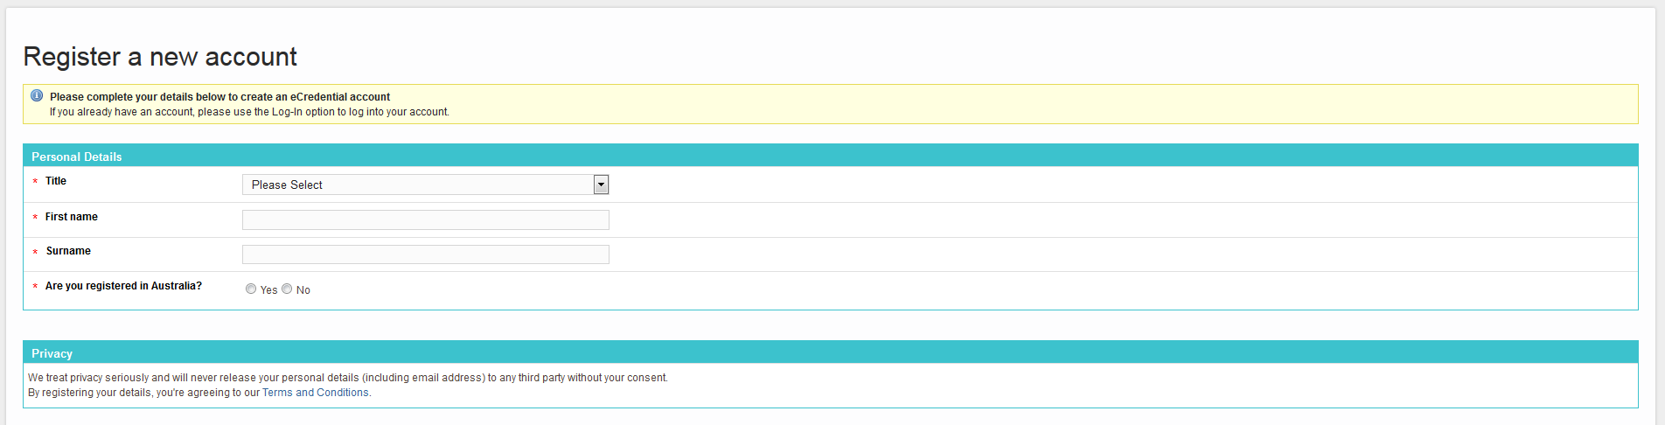

- Enter the following details:
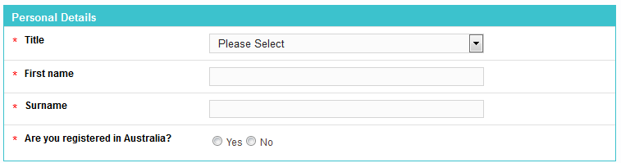
- Title – Select a title from the drop-down list

- First Name – Enter your given name

- Surname – Enter your last name

- Are you registered in Australia?
Select Yes if you have an AHPRA number; then enter your AHPRA number in the field provided.
Click Validate to check the AHPRA number.

If your number is already registered the following message will display:

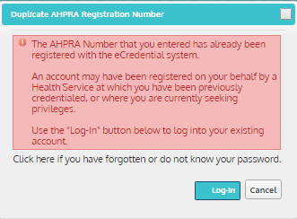
If this message displays, it is likely that you already have an Mercury Credential account. Use the Log-In option to access your account.
If you are not registered in Australia, select No if you do not have an AHPRA number, and enter your date of birth. This is used only to identify users where there is no AHPRA number as a unique identifier.
- Username – enter a username for your new account

- Password – enter a password for your new account - Passwords must be between 6 and 20 characters, with at least one letter and at least one number

- Confirm Password – re-enter your password to confirm

- Email – Enter your email address. All email correspondence and notifications will be sent to this email address.

- Confirm Email – re-enter your email address to ensure you have typed the address correctly.

- Click the Create Account button. A confirmation message displays:

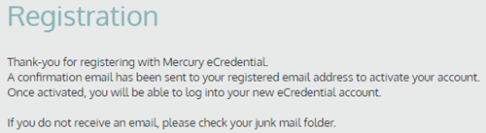

- Check your email for an activation message

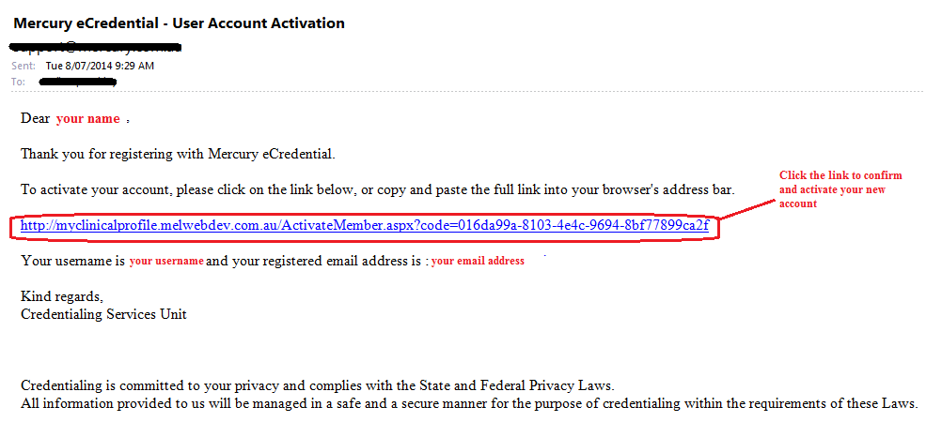
NOTE | If you do not receive an email, please check your junk mail folder.

- Click the link contained within the email. The Activate Account page displays:
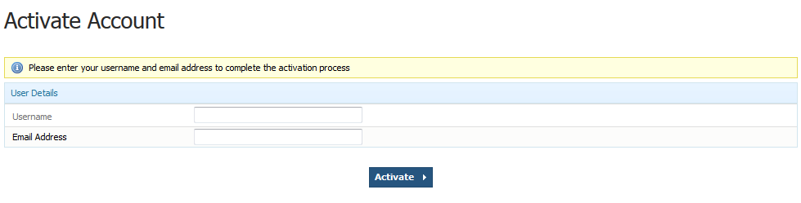
- Enter your username and then your email address. These details are contained within the activation email.

- Click Activate to confirm your details. A confirmation message displays:

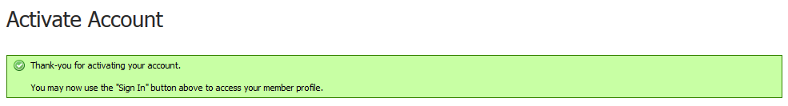
- Use the Log-In link at the top of the screen to Log into your new account.

Log into your Mercury Credential account

If you already have an Mercury Credential account, you can Log-In as follows:
- Open the Mercury Credential myclinicialprofile site - myclinicalprofile.com.au
- Click Log-In at the top right of the screen. The following page displays:
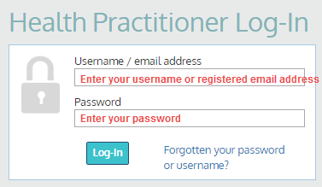
- Type in your username (or registered email address) and your password.

- Click Log-In.

The Personal Details screen displays and you are now logged into your Mercury Credential profile.

Forgotten your Password? Logging in for the first time?

If you forget your password, or if you are logging in for the first time, you can reset your password for your Mercury Credential account as follows:

- Click the Forgotten your password or username? link under the Password field on the Health Practitioner Log-In screen (as below).

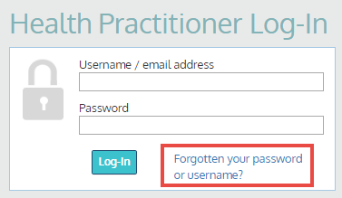

- The Reset Password screen displays:

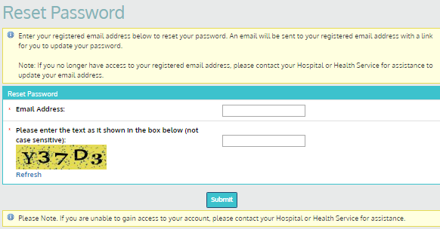
- Type in your email address, and click Next.

A confirmation message displays:

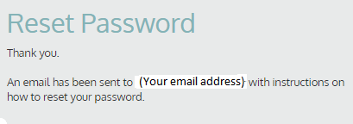

Mercury Credential will send you an email with your username and instructions for resetting your password.

- Go to your email inbox, open the Mercury Credential password reset email.
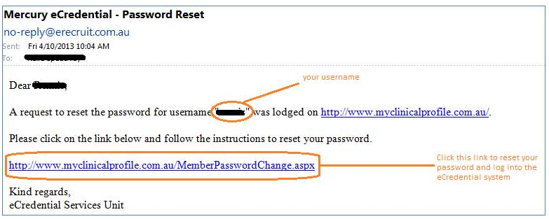
- Click the reset link. NOTE: This link can be used ONCE only.
If you do need to reset your password again, start Steps 1 to 5 again.

- The Mercury Credential Change Password screen displays.

- Type your new password in the New password field. Your password must be between 6 and 20 characters long, and include at least one uppercase letter and one number.

- Confirm your new password by typing it again into the Confirm password field.

- Click Continue. A message displays to confirm your password has been updated.

You can also change your password once you have logged into your account.

Navigating & Managing your profile page
The following areas are key to navigating your profile pages:
- Requests – to view requests to submit your profile for credentialing
- History – to view the history of submissions
- Side-menu – quickly and easily jump to pages within your profile
- My Account – to manage and update details, review profile and more
- Log-out – to log out of the system

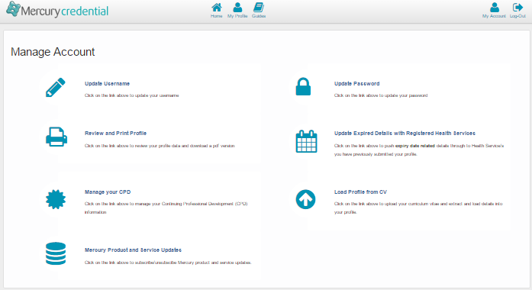

TIP | To step through each page of your profile using a Wizard – use the Next button at the bottom of the page:

Change your username
- In the Tools area at the bottom of the left-hand navigation menu, click Update User Name. The Update User Name screen displays:
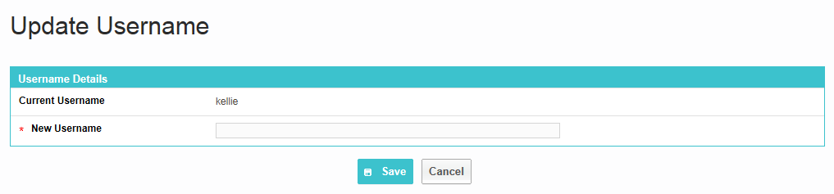
- Enter a new unique user name.
- Click Save to update your user name

Update your password
To update your Mercury Credential password:

- In the Tools area at the bottom of the left-hand navigation menu, click Update Password.
The Update Password page displays:
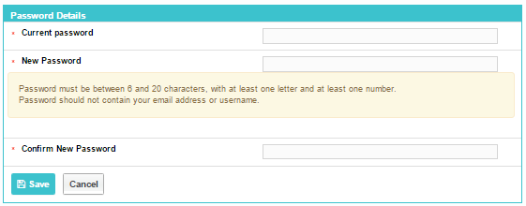
- Enter your Current Password, then your New Password. Your password must be between 6 and 20 characters long, and include at least one uppercase letter and one number.

- Re-enter your new password to ensure you have not mistyped your password

Review / Print / Download your profile
- Select the Review and Print Profile option within the Manage Account section of the main navigation menu.
- Your profile will display in a read-only format. You can choose to either:
- Download your profile as a PDF by selecting the Download Profile As Pdf button at the top of the screen.
- Print your profile by using the print option within your browser.
NOTE | Your profile image will not be included within the printed version.

Manage your profile image
An image can be stored against your profile for identification purposes.

You can manage your profile image as follows:
  - Upload a profile Image
  - Change a profile image
  - Delete a profile image

Upload a profile image
- Select Click to Edit below the portrait in the left-hand navigation menu. The Profile Image screen displays.

- Upload a photo by clicking the Choose File option. The document browser opens.

- Select the photo you want to upload, click Open. A link to your document displays on the screen.

- Click Save to add your photo to your profile.

NOTE | Acceptable file types for profile images are: .jpg, .jpeg, .gif and .png

Change your profile image
Where you have already uploaded a profile image, you can change your profile image as follows:
- Select Click to Edit in the left-hand navigation menu to select an alternative image for your profile

- Click Choose File to open the document browser and select the photo to upload
- Click Open. A link to your document displays on the screen.

- Click Save to add the image to your profile.

Delete your profile image
You can delete the profile image on your profile as follows:

- Select the image in the left-hand navigation menu

- Click Remove Photo to remove the existing image from your profile. The Confirm Delete message displays.

- Confirm to remove the photo from your profile by clicking Ok.

Deactivate your Account
If you no longer wish to use your Mercury Credential account, you can deactivate your account as follows:

- Locate an email in your inbox from Mercury Credential.

- At the end of each email, there is a hyperlink to Unsubscribe from the Mercury Credential system.

- Click the hyperlink. Your browser loads and displays the Unsubscribe from Mercury Credential Service screen.

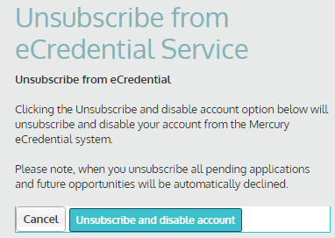

NOTE | By unsubscribing from Mercury Credential, all pending applications and future opportunities will be automatically declined.

- Select the option to Unsubscribe and disable account to continue and deactivate your account. Otherwise select Cancel.

Completing and updating your profile
Now that you have an Mercury Credential account, you can add or change the details in your personal profile. In this section learn how to add and update:
- Personal information, including your address, contact details and your emergency contact details
- Professional information
- Your login details, including your user name and password
- Your profile photo

NOTE |  | When you update details on your profile, this will not update or impact details on applications which you have previously submitted.
TIP | - All fields on the screen that are marked with a red asterisk * are mandatory and must be completed in order to save an open profile page.  - Areas within your profile which are complete display a green tick symbol this enables you to easily recognise areas of your profile yet to be completed.  - To edit details already added to your profile, click the Edit button.  - Details can be removed by clicking the Delete button.

Complete / Update your Mercury Credential profile
When you first access your account, proceed through the following steps to complete all required details within your profile. You can then update your profile as required when details change.

- First, Log Into Mercury Credential. The Personal Details (Step 1 of 11) screen displays, this is the first page of your Mercury Credential profile.

Personal Details (Step 1 of 10)
The Personal Details step captures the following details:
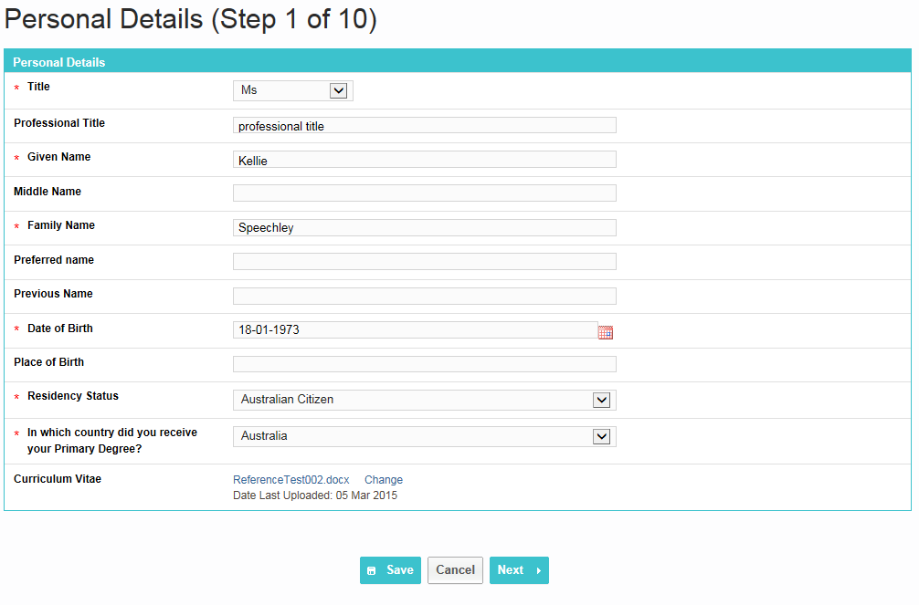
- Enter your personal and registration details:
- Title – Select your title from the drop-down list
- Professional Title – where appropriate, enter a professional title
- Given Name – Enter your legal first name
- Middle Name - Enter your legal middle name
- Family Name - Enter your legal surname
- Preferred Name- Enter your preferred name
- Previous Name - Enter a previous name
- Date of Birth – Enter or select from the calendar, your date of birth
- Place of Birth – Enter the country in which you were born
- Residency Status – Select your current residency status from the following options:
  - Australian Citizen
  - Australian Permanent Resident
  - Australian Temporary Resident
  - New Zealand Resident
  - Not an Australian Resident

If the Residency Status field is set to Australian Temporary Resident or Other, then further visa questions will display for completion:
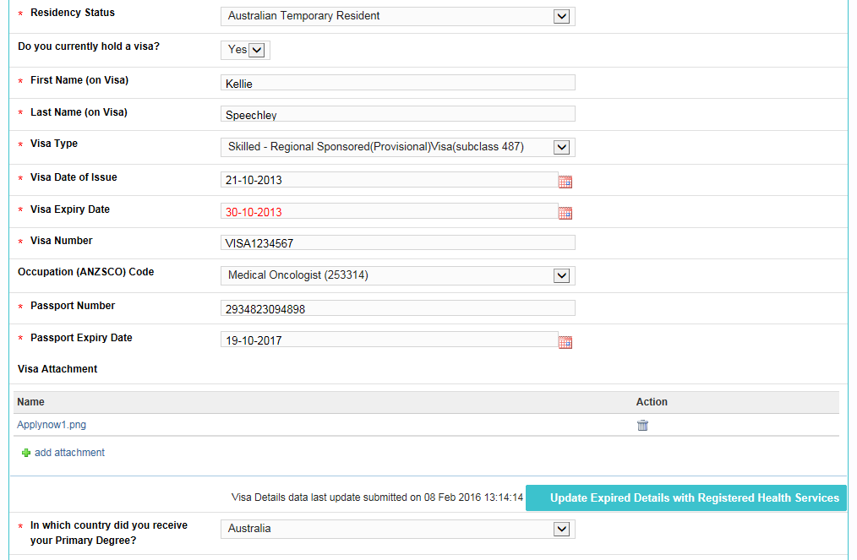

- First Name (on visa) – enter your given name as recorded on your visa
- Last Name (on visa) – enter your surname as recorded on your visa
- Visa Type – enter the type of visa recorded on your visa
- Visa Date of Issue – enter the date on which your visa was issued
- Visa Expiry Date – enter the date on which your visa expires
- Visa Number enter your visa number
- Occupation (ANZSCO) Code - select the ANZSCO code associated with your visa from the drop-down list
- Passport Number - enter your passport number
- Passport Expiry Date- enter the date of your passport expiry
- Visa Attachment – upload a copy of your visa

- Upload a copy of your CV using the Browse button the Curriculum Vitae field.
Browse to locate a copy of your CV to upload.

- Select which country you received your primary degree in from the drop down menu.

If the country in which you received your degree does not display within the list in this field, select the option of Other. Additional questions regarding English Tests and the AMC MCQ display for completion.

- Click Next to continue.

Contact Details (Step 2 of 10)
- Enter your personal and professional contact details in the following sections.

- Contact Details – enter your email address/ect
  - Contact Email Address - enter your primary email address
  - Web sites, blogs or social media links – add links that may be relevant to your profile

You can use the predictive address field to auto-populate your address. As you start to type your address, the system will display close matches:
- Professional Address – enter details pertaining to your professional address:
  - Address, City, State, Postcode, Country
  - Phone – Enter your phone number
  - Fax – Enter a FAX number where appropriate
  - Mobile / Pager – enter your mobile contact number

- Residential Address- enter details pertaining to your place of residence:
  - Address, City, State, Postcode, Country
  - Phone (BH) – Enter your phone number
  - Fax – Enter a FAX number where appropriate
  - Mobile / Pager – enter your mobile contact number

- Postal Address – Select to copy your address from your Professional Address, or Residential Address, or enter different details for your postal address where this differs to your residential or professional addresses:
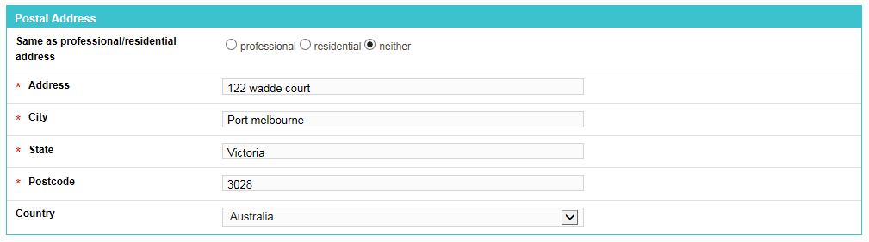
  - Address, City, State, Postcode, Country

- Emergency contact details (optional). - Name, Relation, Address, City, State, Postcode, Country, Phone (BH & AH), Mobile

- Click Next to continue.

Qualifications (Step 3 of 10)
- Click +add qualification to add a qualification to your profile.
The Add New Qualifications Activities pop-up window displays:
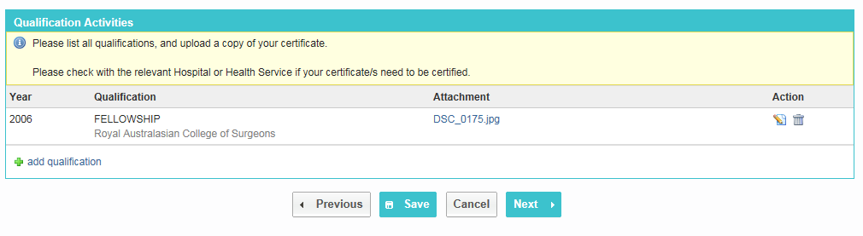
- Enter details pertaining to the qualification using the following fields:
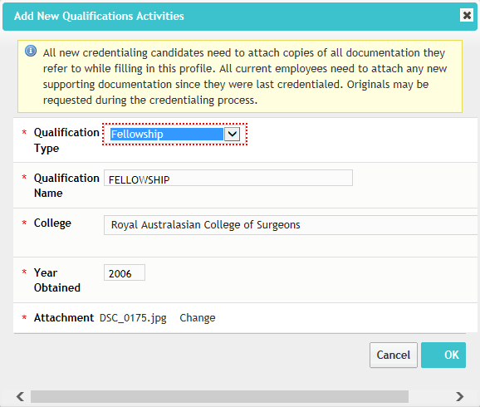
- Qualification Type - Select type of qualification from one of the following options:
  - Degree
  - Fellowship
  - Certificate
  - Graduate Certificate
  - Associate Diploma
  - Diploma
  - Graduate Diploma
  - Masters Degree
  - Professional Doctorate
  - PhD

Where Degree, Masters Degree, Professional Doctorate or PhD:
- Qualification name - enter the name of your Degree/Qualification in this field.
- University / Institution - Select a University or Institution from the drop down menu in this field. Where your University or Institution is not listed, select the option of Other and enter the name of your University or Institution in the Other University field which subsequently displays.
- Year Obtained - Enter the year you obtained your qualification
- Attachment – add a document to validate your qualification.
- Click Browse. The document browser opens.
- Select the document you want to upload, click Open. A link to your document displays on the screen.
- Click Ok. Your qualification has been added to your profile.

Where Fellowship:
- Qualification name – enter further details regarding the fellowship.
- College - Select a college from the drop down menu in this field. Where your college is not listed, select the option of Other and enter the name of your University or Institution in the Other University field which subsequently displays.
- Year Obtained - Enter the year you obtained your qualification
- Attachment – add a document to validate your qualification.

Where Certificate, Graduate Certificate, Associate Diploma, Diploma and Graduate Diploma:
- Qualification name – enter further details regarding the fellowship.
- Institution - Enter the name of your college, university or institution in the field
- Year Obtained - Enter the year you obtained your qualification
- Attachment – add a document to validate your qualification.

- To add more qualifications repeat above steps.

- Click Next to continue.

Employment History (Step 4 of 10)
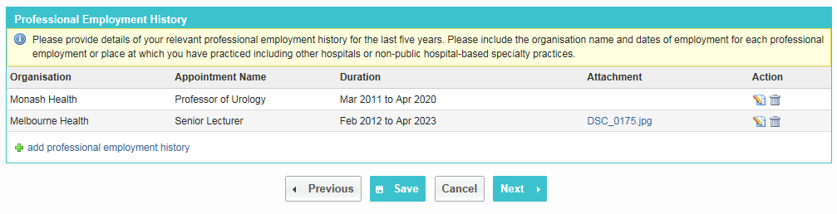Provide details of all current and previous clinical appointments held within the last five years (including names of organisations and dates of appointment) or other places of practice (for example, other hospitals or non-public hospital-based specialty practice).

- Click +add professional employment history, the Add New professional employment history pop-up window displays. Enter the following details for the clinical appointment :
- Organisation – enter the name of the Organisation where your appointment was.
- Name and type of appointment - Enter the name of the appointment and type of appointment.

- Duration - Select the dates of the appointment duration.

- Attach a copy of supporting documentation:

- Click Browse to open the document browser.
- Select the document to upload and click Open. A link to your document displays on the screen.
- Click Save to add the appointment to your profile.

- To add more appointments repeat steps 18 – 20.

- Click Next to continue.

Registration (Step 5 of 10)
Add your Medicare Provider Number/s to your profile.

- Click +add Medicare provider number, the Add Medicare Provider Number pop-up window displays:
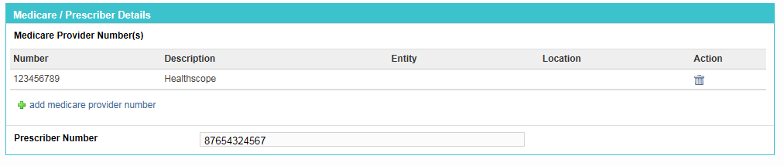
- Enter the following details for the clinical appointment
- Medicare Provider Number – enter your Medicare provider number
- Description - Enter a description if required
- Entity - Select an organisation to whom this is relevant (this also displays location options depending on the entity selected)
- Location – Select a location if your Medicare provider number is location specific

Click Save to add the prescriber number to your profile.

- Enter your Prescriber Number

- For the question Do you have an AHPRA Registration Number? select:
- Yes – you will be asked for further details regarding your registration number and type.
- No – if you do not have an AHPRA National Medical Registration Number.
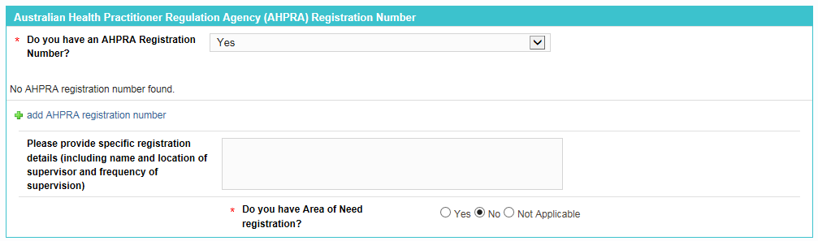

- Click the +add AHPRA registration number link to add an AHPRA number

- Respond to the Registration questions:
- Please provide specific registration details (including name and location of supervisor and frequency of supervision)
- Do you have Area of Need registration?
- If you have registration pertaining to an Area of Need, please detail the type of assessment process undertaken prior to achieving full registration

- If you are registered with ASAR or have a Victorian Radiation Use Licence, add your registration number by clicking the +Add link in the relevant section:
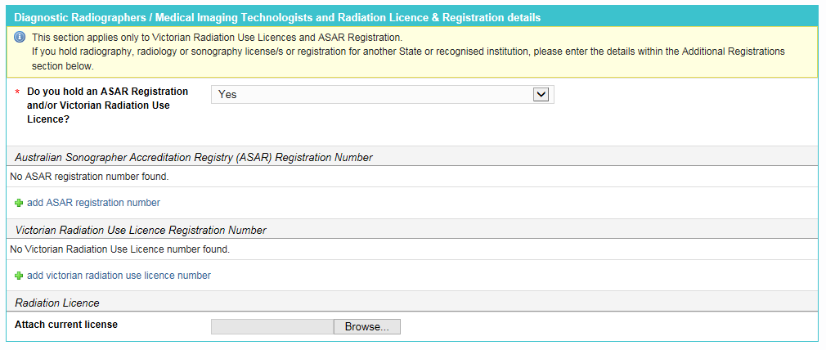
A validate option will verify your details against the relevant database.

- Enter any Additional Registrations you may have by clicking the +add registration details link. Enter the following details for the registration
- Registration Type
- Registration Number – enter the registration number
- Description - Enter a description if required
- Expiry Date – select the date on which the registration expires
- Attachment– add an attachment where relevant

Click Save to add the Registration details to your profile.

- Record an ABN/CAN number against your profile by selecting the +add ABN/ACN Number link

- Complete the questionnaire by selecting either Yes or No for each question.

- Enter details for any Overseas Registrations you have:
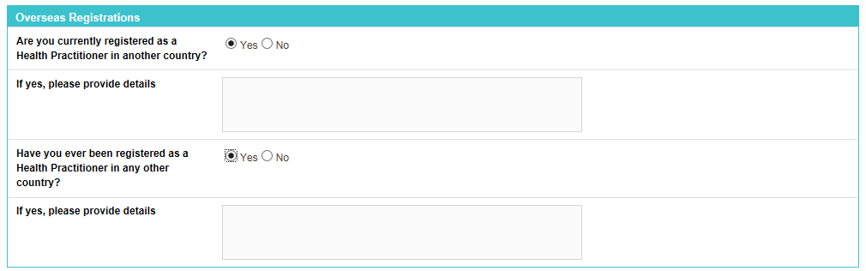
- Click Next to continue.

Insurance Information (Step 6 of 10)
Step 6 captures details relating to your current medical and professional indemnity insurance cover.

- Respond to the questions regarding indemnity:
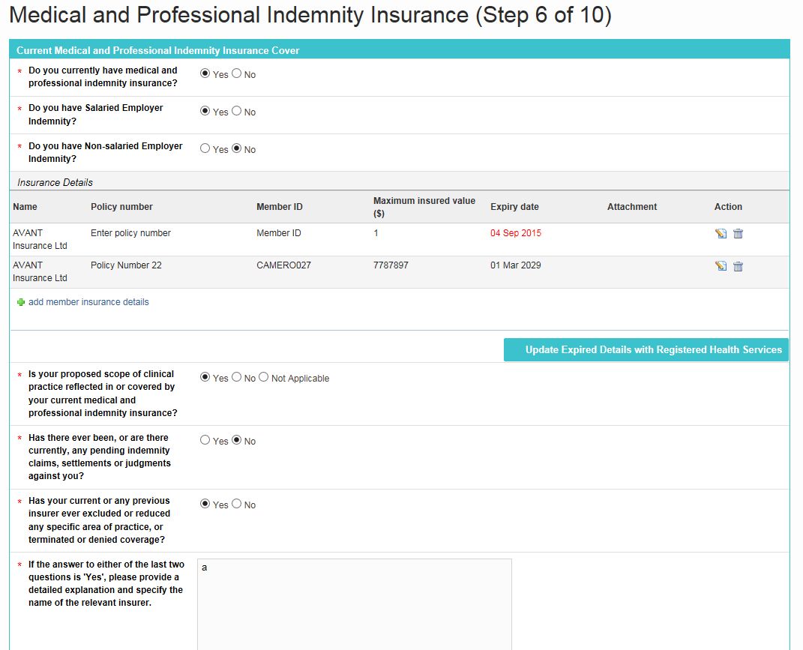

- Do you currently have medical and professional Indemnity Insurance? Select either Yes or No.
- Do you have Salaried Employer Indemnity? Select either Yes or No.
- Do you have non-salaried Employer Indemnity? Select either Yes or No.

- Where you have selected Yes to the question, Do you currently have medical and professional Indemnity Insurance? add insurance details by clicking the +add member insurance details link to add a set of insurance details:
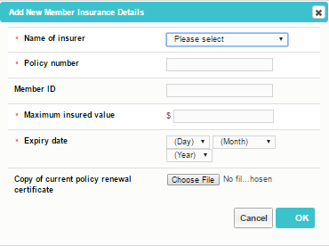
- Enter the following details for insurance by clicking the +add indemnity details link:
- Name of Insurer - enter the Name of Insurer
- Policy Number - enter the Policy Number
- Member ID – enter your personal Member ID
- Maximum Insured Cash Value ($) – enter the Maximum insured cash value for the insurance
- Expiry Date – enter the Expiry Date for the insurance
- Copy of current policy renewal certificate - Attach a copy of current policy renewal certificate:
  - Click Browse and the document browser opens
  - Select the document you want to upload, click Open. A link to your document displays on the screen.

- Note. Should Avant insurance be selected, the Member ID field will become mandatory.
- Complete questions regarding current and previous indemnity insurance.

- Enter any other Indemnity details in the Other Indemnity section:
- Name- enter a name
- Description – enter a description
- Type – enter a type

- Click Next to continue.

Academic Appointments / Teaching Experience (Step 7 of 10)
At Step 7, you can provide details of current and previous university or hospital teaching appointments held within the last five years.

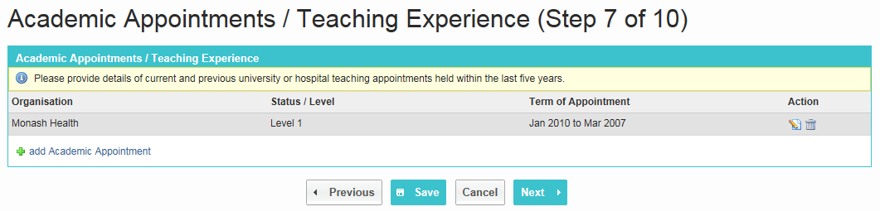

- Click +add Academic Appointment, the Add New Academic Appointments pop-up window displays:

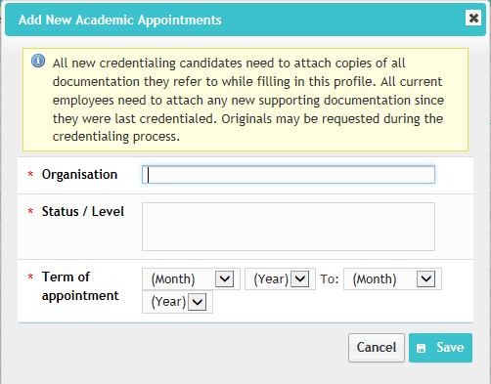

- Enter details regarding your academic appointment using the following fields:
- Organisation - Type in the name of the Organisation.
- Status / Level - Enter the Status or Level of the appointment
- Term of Appointment - Select the dates for the Term of appointment.

- Click Save to save the details. Repeat steps to add more academic appointments.

- Click Next to continue.

Professional Development (Step 8 of 10)
At this step, you can provide details of any CPD you are currently or have previously completed, including:
- College CPD
- CPD
- Quality related activities
- Publications

NOTE | Usually you will need to complete at least one set of details against one of the above 4 sections.
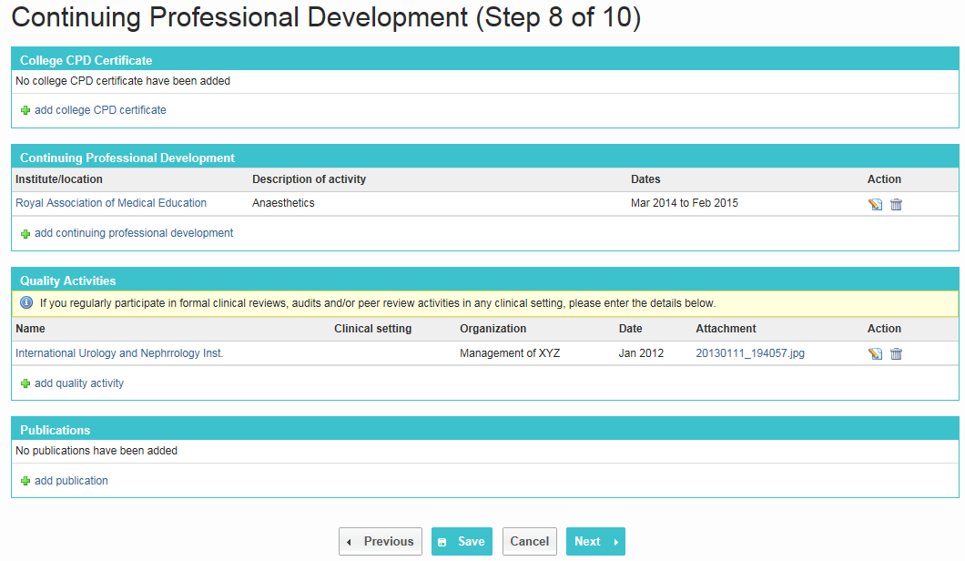
- Click +add college CPD Certificate, the Add New College CPD Certificate pop-up window displays. Enter the following details:
- Name – Enter the name of the institute at which the course was taken
- Description - Enter a brief description of the course undertaken
- Dates– Select the dates during which you participated in the CPD.
- Attach a copy of your documentation; Log Book, Activity and / or Certificates. Click Browse and the document browser opens.

- Click +add continuing professional development, the Add New Continuing Professional Development pop-up window displays.
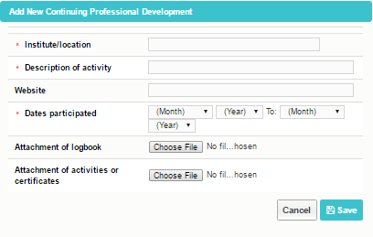
Enter details regarding your professional development using the following fields:
- Institute – Enter the name of the institute at which the course was taken
- Description - Enter a brief description of the course undertaken
- Website – Enter a website for the course where relevant
- Dates of Participation – Select the dates during which you participated in the professional development.
- Attach a copy of your documentation; Log Book, Activity and / or Certificates. Click Browse and the document browser opens.
- Select the document you want to upload, click Open. A link to your document displays on the screen.
- Click Ok. Now your CPD has been added to your profile.

You can also add Quality Activities, Publications in the subsequent areas on this screen.

- Click Next to continue.

Background Checks (Step 9 of 10)
The Background Checks page captures details relating to criminal record screens, working with children checks etc.
NOTE | Depending on the organisation to which you are submitting your profile, this page may be optional, or may be required.  Where required, you will need to complete at least one set of details on this page.

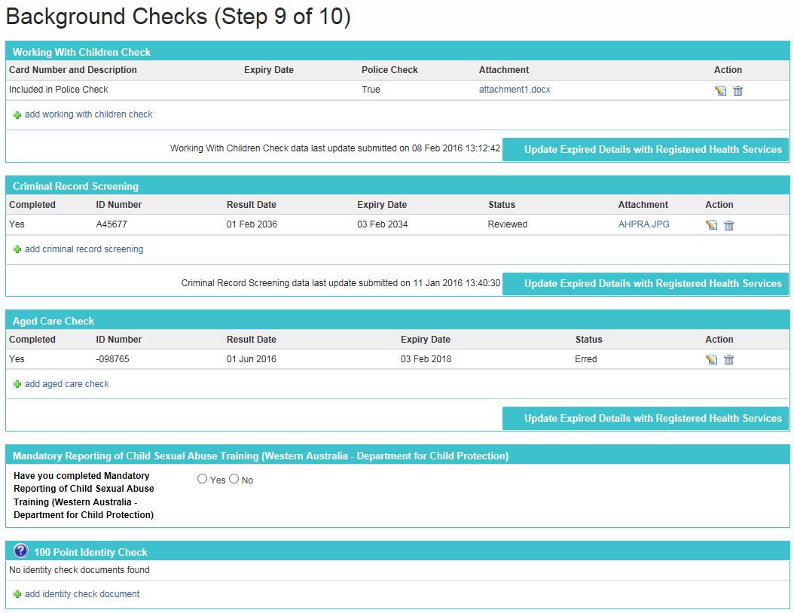

- Click +add working with children check, the Add New Working With Children Check page displays. Enter the following details:
- Is the working with children check included in your police check? - Select yes or no.
- Card Number – enter the card number
- Card Description- enter a description where relevant
- Expiry Date – enter the expiry date of the working with children check
- Attachment – attach evidence of the working with children check

- Click +add Criminal Record screening, the Add Criminal Record Screening pop-up displays.

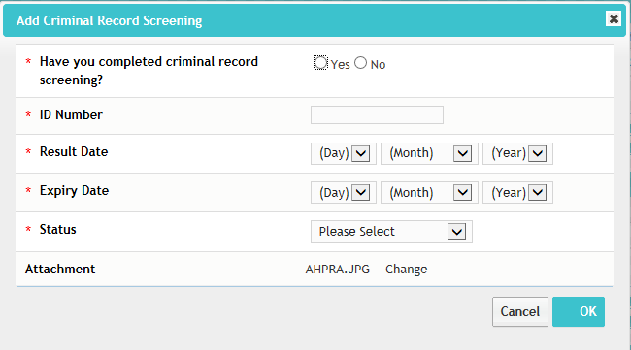

Enter the following details:
- Have you completed criminal record screening? - Select yes or no.
- Id Number – enter the id number for the screening
- Result Date- enter the result date for the screening
- Expiry Date - enter the expiry date for the screening
- Status – enter the status of the screening
- Attachment – upload evidence of your screening (optional).

- Click +add Aged Care Check, the Add Aged Care Check pop-up window displays. Enter the following details:
- Have you completed an Aged Care check? - Select yes or no.
- Id Number - enter the id number for the check
- Result Date- enter the result date for the check
- Expiry Date - enter the expiry date for the check
- Status – enter the status of the check

- Select Yes or No against the question of Mandatory Reporting of Child Sexual Abuse Training. This question is relevant for Western Australian users only.

- Add 100 Point Identity check documents and details by clicking the +add identity check document link
A downloadable PDF document is available by clicking the against the 100 point ID check section, which outlines the points allocated for each type of identification document.
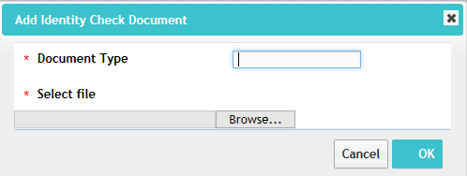
Enter the following details:
- Document Type – enter a document type to display as a description.
- Attach a copy of your documentation by clicking Browse; the document browser opens

Referees (Step 10 of 10)
Enter referee contact details at Step 10. You can also attach references or additional referee details where required within the Referee Attachments section of this page.

- Click +add new reference, the Add Referee page displays:
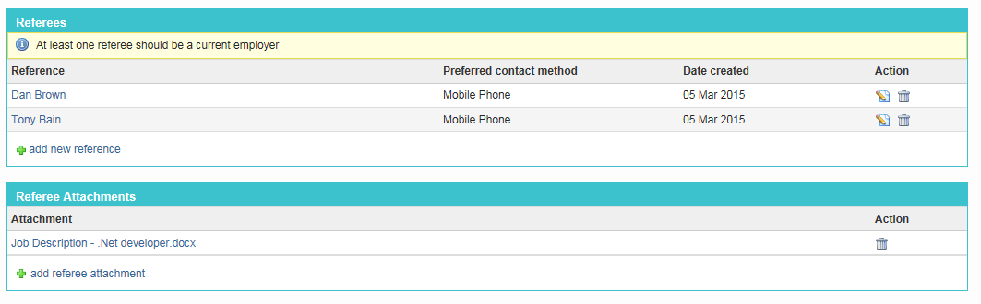
- Enter the Referee contact and address details.

- Click Save to add the referee details to your profile.

NOTE | The number of referees you will need to submit depends on the organisation to which you are submitting your profile. Usually you will need to provide a minimum of two referees.

- Once complete, click Save and Complete.

A message displays confirming your profile has been successfully updated.

Submitting your profile for Credentialing

In this section learn how to:
- Submit your profile for credentialing against a position in Mercury Credential
- Check the status of credentialing requests you have submitted.
- View your previous credentialing requests

Submit your Profile against a position
When you are invited to submit your profile for credentialing, your hospital will send you a credentialing request. Navigate to the Home screen to see any pending requests.

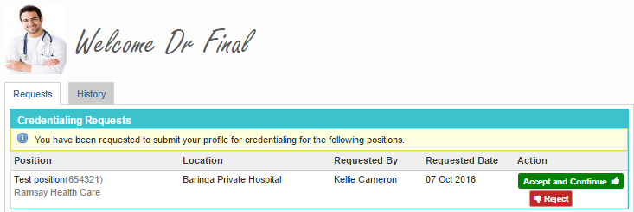

Within the Credentialing Requests section on this screen, any positions you have been requested to submit your profile to be credentialed against display.

Available options
Apply Now – start the submission process to send your profile to the organisation
Reject – remove the application from the list- this will cancel this application.

Submit your profile for credentialing by following these steps:

- Click the Accept and Continue button next to the position you want to submit your profile for.

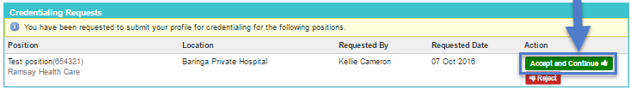

- Your profile displays on the screen for you to review. If there are any areas of your profile which are mandatory and still require completion, you will see a reminder at the top of the screen:
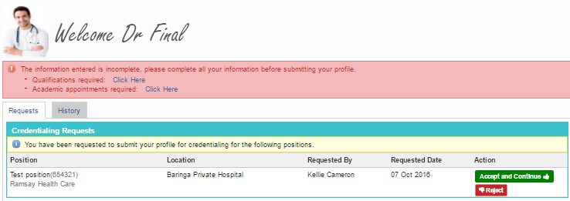

- A summary of your profile displays. Review your profile and click the Edit button next to any area you need to update on your profile.
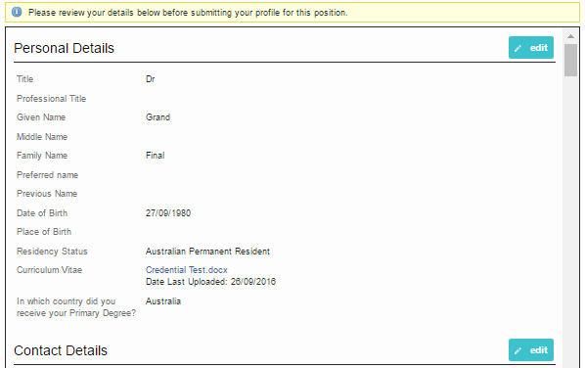
- Scroll to the bottom of the screen, and when your profile is ready, click Next. The Agreement/Undertakings screen displays.

- If the organisation you are submitting your profile to has some specific questions, these display for you to complete: These questions are organisation-specific and generated specifically for the position against which you are submitting your profile.

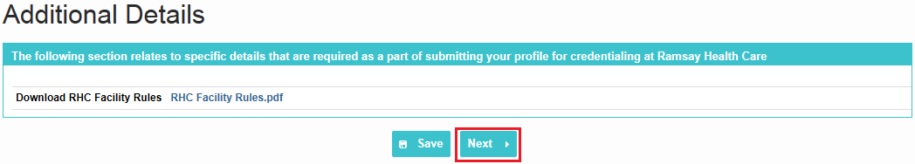
- Respond to these questions, and then click Next

- Review and respond to the Health Status questions by selecting Yes or No. Specific details regarding a disability or health issues can be entered in the text box provided.

- Review and respond to the organisation specific declarations / By-Law questions. Complete the Declaration questions by selecting Yes or No for each question listed. Once all questions are answered, click Next to continue.

- The Submit For Credentialing screen displays. In the Scope of Practice area select the procedures you are able to undertake. Only select procedures you are capable of performing.

NOTE | At least one procedure must be selected on the scope of practice in order for you to submit your profile for the position.

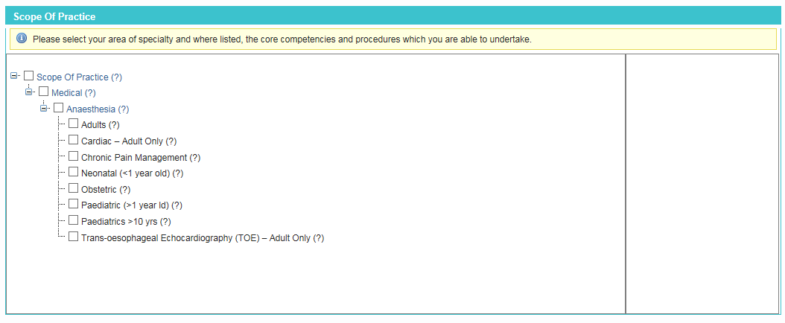

- Click Submit Profile to submit your profile for credentialing.
A message displays confirming your profile has been successfully submitted.

NOTE | If you don’t see a confirmation message, please review your submission to ensure you have completed the whole submission process.

- Repeat this process for each position you have been requested to submit you profile to.

TIP | Once you have submitted your profile for credentialing, your details will be reviewed by the organisation you submitted to.  If there are areas which require further clarification, you may be requested to supply more details, or documents. Your application will be returned to you for updating and can be accessed via the Credentialing Requests that require further details section within the Pending Requests screen.

Requests requiring further details
Once you have submitted your profile for credentialing, your details will be reviewed by the organisation you submitted to.

If there are areas which require further clarification, you may be requested to supply more details, or documents.
Your application will be returned to you for updating and can be accessed via the Credentialing Requests that require further details section within the Pending Requests screen:
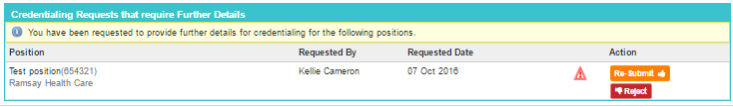

Action the request as follows:
Available options
Details Required – click to review comments from the requestor
Re-Submit – re-submit your details after updating the areas requiring attention
Reject – remove the application from the list- this will cancel this application.

Manage who has access to your Account
On occasion, you may require assistance with your profile, or an organisation may offer to load details against your account on your behalf. To do this, an organisation may request temporary access to your account.

You can manage who has access via the Manage Account Access menu, which will appear in the main toolbar when a request is submitted.

Each organisation has the ability to request access to your account – for the purpose of assisting you with completing your profile. There are two types of access:
Access types
Temporary Access Request | Organisations for which you have granted access, will be provided with 14 days access to modify your profile on your behalf, after which their access will expire.  The organisation cannot view your applications or application history.
On Behalf of Access | Organisations for which you have granted access, will be able to update your profile and submit applications on your behalf.  Where the organisation submits on your behalf, you will receive an email notification which you must review and approve before your profile will be submitted for credentialing.

From the Manage Account Access page, you will see pending and historic Access requests as follows:
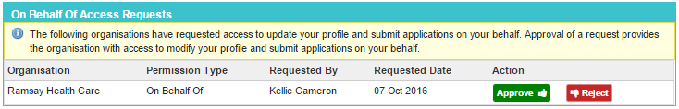

Available options
Accept the request and provide access to the requesting organisation
Reject the request
Revoke the access previously provided to an organisation.

Update Expired Details with Registered Health Services

In this section, learn how to:
- Update your details which are expiring, or have expired.
- Submit your updated details

Each time you submit your profile for credentialing against a position to an organisation, Mercury Credential captures a snap-shot of the details you submit.

A number of areas within the clinical profile include dates which may expire. For example, Police checks, training certifications, visas, passports etc.

Whilst you may only be credentialed once every couple of years, various insurances/training etc. may expire in the interim.

You can update dates within their profile, and push these new details through to organisations with which you have previously submitted your profile by using the Update Expired Details with Registered Health Services option.

NOTE | Please note: This function sends updated details to all active positions for which you have been credentialed or are currently being credentialed.  This will only push Expiry Date-related details through to the Health Service/s – please see table below. Other information will not be submitted.

The following details can be updated within your profile and re-submitted to organisations to which you have previously submitted your profile:
Area | Fields included in the update
Visa Details | Residency Status, First Name (on Visa), Last Name (on Visa), Visa Type, Visa, Date of Issue, Visa Expiry Date, Visa Number, Occupation (ANZSCO) Code, Passport Number, Passport Expiry Date, Visa Attachment
Additional Registrations | Type, Number, Description, Expiry Date, Attachment, Last Updated
Aged Care Check | Completed (yes/no), ID Number, Result Date, Expiry Date, Status
Criminal Record Screening | Completed (yes/no), ID Number, Result Date, Expiry Date, Status
Working With Children Check | Card Number and Description, Expiry Date, Policy Check (yes/no), Attachment
Insurance Details | Name, Policy Number, Maximum Insured Cash Value, Expiry Date, Primary (yes/no), Attachment

To push updated details, you can use either:
- The bulk option of sending all updated details at once via the Update Expired Details with Registered Health Services link available under the ‘Manage Account’ option of your profile:
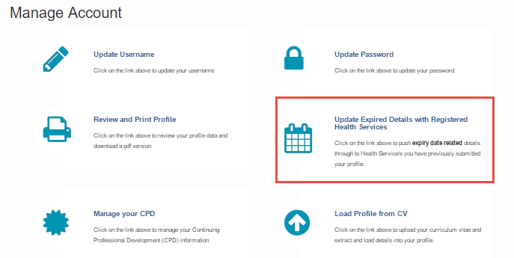
Or,
- Individual sets of details by using the Update Expired Details with Registered Health Services button which displays against sections which can be re-submitted:

For the bulk submit option, a summary screen of expiry related details display, as well as the last submitted dates. You can then choose which sections to re-submit.
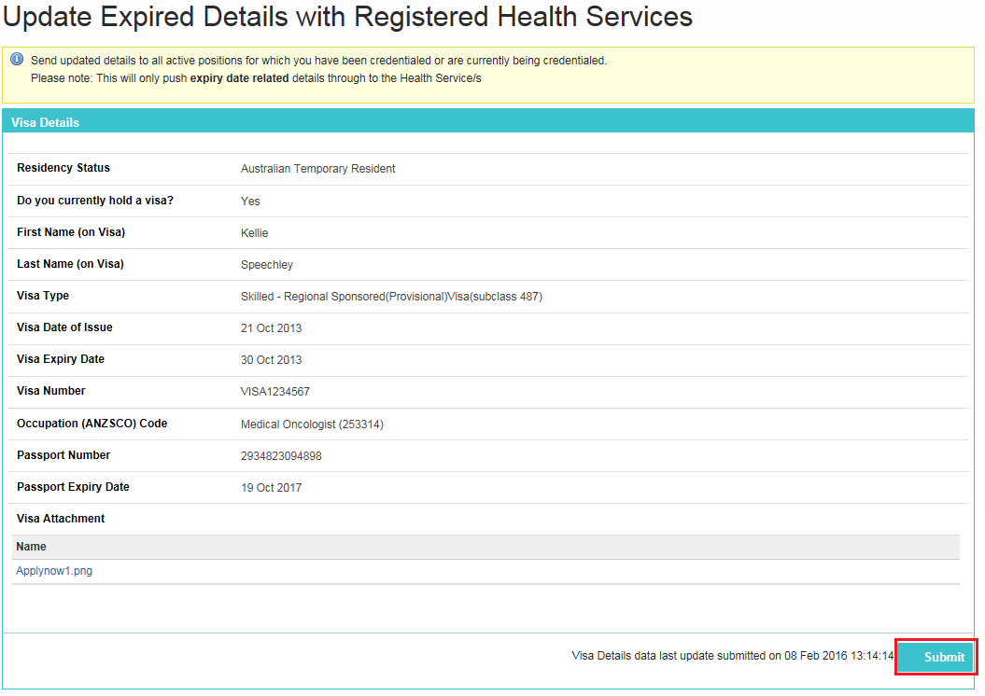

For the single area option, a pop-up window displays to allow you to review the details being submitted:

When successfully submitted, the screen logs the last date of submission:

The details you submit will be sent to each organisation with which you have previously submitted your details.

Index

Logging in for the first time…………………..………… 8
Managing your profile
Completing your profile…………………………......14
Create a new account……………............................4
Submit your profile for credentialing……………….29
Update your password………………………………11
Mercury Credential
Access Mercury Credential system…………………….…….3
Deactivate account…………………………….........12
Log into Mercury Credential…………………………………..7
Passwords
Update your Password………………….......……...11
Forgotten……………………………………………….8
Reset……………………………………………………8
Profile
Academic Appointments / Teaching Experience…23
Background Checks…………………………………26
Contact details
Email Addresses………………………………….16
Postal Address……………………………………16
Professional Address…………………………….16
Residential Address……………….……………..16
Continuing Professional Development (CPD)……24
College CPD………………………………………24
Publications………………………………………..25
Quality Activities…………………………………. 25
Employment History…………………………………18
Image -Upload / Change / Delete profileimage…..12
Personal details……………………………………...14
Passport Details…………………………………..15
Residency Status…………………………………14
Visa Details………………………………………..15
Professional Indemnity Insurance………………….21
Qualifications…………………………………………16
Referees………………………………………………28
Registration Details………………………………….19
AHPRA Number…………………………………..19
Medicare Provider Number………………………19
Overseas Registrations…………………………..20
Prescriber Number………………………………..19
Review, print, download profile………………….11
Username
Change username (Applicant)…………………….............................10

